# **[Android Studio Rename Package](https://stackoverflow.com/questions/16804093/android-studio-rename-package)**

In Android Studio, you can do this:

For example, if you want to change com.example.app to my.awesome.game, then:

1. In your ***Project pane***, click on the little gear icon ( Gears icon )
2. Uncheck / De-select the Compact Empty Middle Packages option

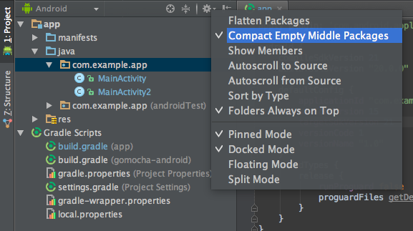

1. Your package directory will now be broken up in individual directories
2. Individually select each directory you want to rename, and:
   * Right-click it
   * Select Refactor
   * Click on Rename
   * In the Pop-up dialog, click on Rename Package instead of Rename Directory
   * Enter the new name and hit **Refactor**
   * Click **Do Refactor** in the bottom
   * Allow a minute to let Android Studio update all changes
   * *Note: When renaming com in Android Studio, it might give a warning. In such case, select***Rename All**

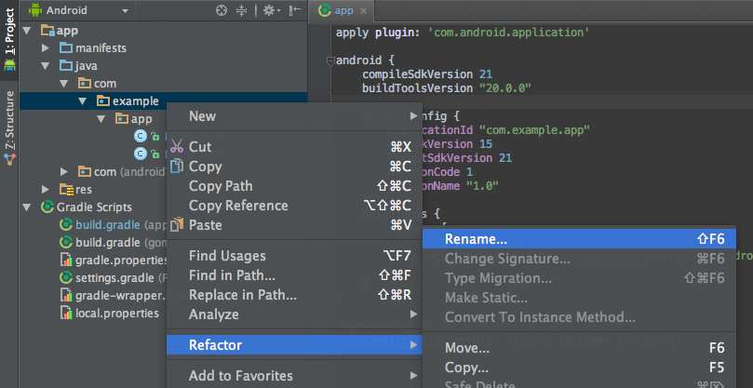

1. Now open your ***Gradle Build File*** (build.gradle - Usually app or mobile). Update the applicationId to your new Package Name and Sync Gradle, if it hasn't already been updated automatically:

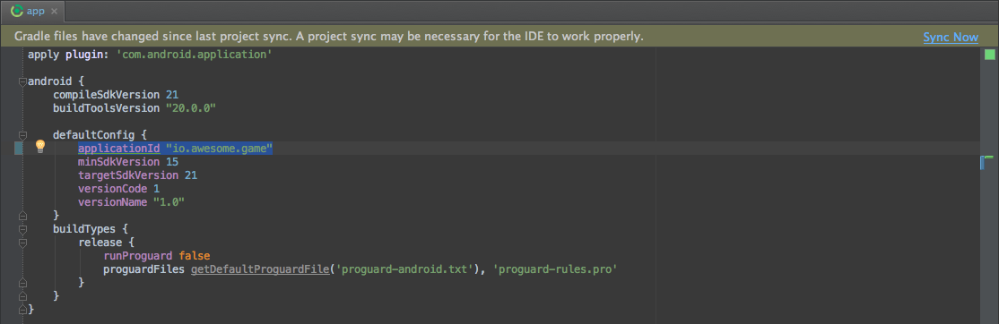

1. You may need to change the package= attribute in your manifest.
2. Clean and Rebuild.
3. ***Done!*** Anyways, Android Studio needs to make this process a little simpler.